MLDL
PRACTICAL 2
Name: Payal Dara
Class: D15C
Roll no: 56
Batch: C

Aim: To implement Multiple Regression , Ridge Regression and Lasso Regression on a real-life dataset.

1. Dataset Source
The dataset used for this experiment is the Heart Disease Dataset, obtained from Kaggle.
Source:
https://www.kaggle.com/datasets/johnsmith88/heart-disease-dataset

2. Dataset Description
The Heart Disease Dataset is a real-world medical dataset used to predict the presence of heart disease in patients based on various clinical attributes.
The dataset contains 1025 instances and 14 attributes, out of which 13 are input features and 1 is the target variable. The features include patient information such as age, gender, chest pain type, resting blood pressure, cholesterol level, fasting blood sugar, ECG results, maximum heart rate, and exercise-induced angina.
The target variable indicates whether a patient has heart disease:
- Target = 1 → Presence of heart disease
- Target = 0 → Absence of heart disease
The dataset consists of both numerical and categorical features, making it suitable for regression with regularization techniques.

3. Mathematical Formulation of the Algorithm

Ridge Regression (L2 Regularization)
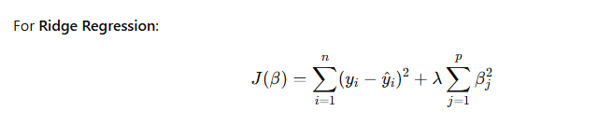

Lasso Regression (L1 Regularization)
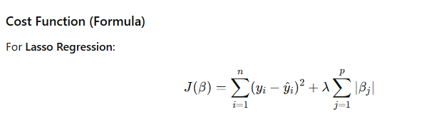

4. Algorithm Limitations

Ridge Regression Limitations
- Does not perform feature selection
- All features remain in the model
- Less effective when many irrelevant features exist

Lasso Regression Limitations
- Unstable when features are highly correlated
- May arbitrarily select one feature and discard others
- Performance depends heavily on the choice of ( \lambda )

5. Methodology / Workflow
The experiment was conducted using the following steps:
- Load the Heart Disease dataset
- Separate features and target variable
- Split the dataset into training and testing sets
- Perform feature scaling using standardization
- Train Ridge and Lasso regression models
- Predict results on the test dataset
- Evaluate model performance using error metrics
- Compare coefficients and results

6. Performance Analysis
The performance of Ridge and Lasso regression models was evaluated using Mean Squared Error (MSE).
- Ridge regression showed stable performance by reducing coefficient magnitudes and handling multicollinearity.
- Lasso regression produced sparse coefficients by eliminating less important features.
- Both models helped reduce overfitting compared to standard linear regression.
Lower MSE values indicate better model performance and improved generalization.

7. Hyperparameter Tuning
The regularization parameter ( \lambda ) (alpha) was tuned to observe its effect on model performance.
- Different values of alpha were tested
- A higher alpha increased regularization strength
- Ridge regression benefited from moderate alpha values
- Lasso regression showed feature elimination at higher alpha values
Hyperparameter tuning helped in selecting optimal regularization strength, leading to improved prediction accuracy and reduced overfitting.

Code:
Without hypermeter tuning
# ============================================
# MULTIPLE + RIDGE + LASSO (WITHOUT TUNING)
# ============================================

import pandas as pd
import numpy as np
import matplotlib.pyplot as plt

from sklearn.model_selection import train_test_split
from sklearn.linear_model import LinearRegression, Ridge, Lasso
from sklearn.metrics import mean_absolute_error, mean_squared_error, r2_score
from sklearn.preprocessing import StandardScaler

# --------------------------------------------
# Create Dataset (same as your experiment)
# --------------------------------------------
data = {
'age': [52,53,70,61,62,58,58,55,46,54,71,43,34,51,52,34,51,54,50,58,
60,67,45,63,42,61,44,58,56,55,44,50,57,70,50,46,51,59,64,57],
'sex': [1,1,1,1,0,0,1,1,1,1,0,0,0,1,1,0,0,1,0,1,
1,0,1,0,0,0,1,0,1,0,1,0,1,1,1,1,1,1,1,1],
'cp': [0,0,0,0,0,0,0,0,0,0,0,0,1,0,0,1,2,0,1,2,
2,0,0,2,2,0,2,1,2,0,0,1,0,2,2,2,3,0,0,2],
'trestbps': [125,140,145,148,138,100,114,160,120,122,112,132,118,140,128,118,140,124,120,140,
140,106,104,135,120,145,130,136,130,180,120,120,130,160,129,150,125,138,128,128],
'chol': [212,203,174,203,294,248,318,289,249,286,149,341,210,298,204,210,308,266,244,211,
185,223,208,252,209,307,233,319,256,327,169,244,131,269,196,231,213,271,263,229],
'fbs': [0,1,0,0,1,0,0,0,0,0,0,1,0,0,1,0,0,0,0,1,
0,0,0,0,0,0,0,1,1,0,0,0,0,0,0,0,0,0,0,0],
'restecg': [1,0,1,1,1,0,2,0,0,0,1,0,1,1,1,1,0,0,1,0,
0,1,0,0,1,0,1,0,0,2,1,1,1,1,1,1,0,0,1,0],
'thalach': [168,155,125,161,106,122,140,145,144,116,125,136,192,122,156,192,142,109,162,165,
155,142,148,172,173,146,179,152,142,117,144,162,115,112,163,147,125,182,105,150],
'exang': [0,1,1,0,0,0,0,1,0,1,0,1,0,1,1,0,0,1,0,0,
0,0,1,0,0,1,1,0,1,1,1,0,1,1,0,0,1,0,1,0],
'oldpeak': [1.0,3.1,2.6,0.0,1.9,1.0,4.4,0.8,0.8,3.2,1.6,3.0,0.7,4.2,1.0,0.7,1.5,2.2,1.1,0.0,
3.0,0.3,3.0,0.0,0.0,1.0,0.4,0.0,0.6,3.4,2.8,1.1,1.2,2.9,0.0,3.6,1.4,0.0,0.2,0.4],
'slope': [2,0,0,2,1,1,0,1,2,1,1,1,2,1,1,2,2,1,2,2,
1,2,1,2,1,1,2,2,1,1,0,2,1,1,2,1,2,2,1,1],
'ca': [2,0,0,1,3,0,3,1,0,2,0,0,0,3,0,0,1,1,0,0,
0,2,0,0,0,0,0,2,1,0,0,0,1,1,0,0,1,0,1,1],
'thal': [3,3,3,3,2,2,1,3,3,2,2,3,2,3,0,2,2,3,2,2,
2,2,2,2,2,3,2,2,1,2,1,2,3,3,2,2,2,2,3,3],
'target': [0,0,0,0,0,1,0,0,0,0,1,0,1,0,0,1,1,0,1,1,
0,1,1,1,1,0,1,0,0,0,0,1,0,0,1,0,1,1,1,0]
}

df = pd.DataFrame(data)

# --------------------------------------------
# Prepare Data
# --------------------------------------------
X = df.drop(['oldpeak', 'target'], axis=1)
y = df['oldpeak']

X_train, X_test, y_train, y_test = train_test_split(
X, y, test_size=0.25, random_state=42
)

# Scaling
scaler = StandardScaler()
X_train = scaler.fit_transform(X_train)
X_test = scaler.transform(X_test)

# --------------------------------------------
# Models (NO TUNING)
# --------------------------------------------
linear = LinearRegression()
ridge = Ridge(alpha=1.0)
lasso = Lasso(alpha=0.1)

linear.fit(X_train, y_train)
ridge.fit(X_train, y_train)
lasso.fit(X_train, y_train)

# Predictions
y_pred_linear = linear.predict(X_test)
y_pred_ridge = ridge.predict(X_test)
y_pred_lasso = lasso.predict(X_test)

# --------------------------------------------
# Evaluation
# --------------------------------------------
print("\n===== WITHOUT HYPERPARAMETER TUNING =====")

def evaluate(name, y_true, y_pred):
print(f"\n{name}")
print("MAE :", round(mean_absolute_error(y_true, y_pred), 3))
print("RMSE:", round(np.sqrt(mean_squared_error(y_true, y_pred)), 3))
print("R2 :", round(r2_score(y_true, y_pred), 3))

evaluate("LINEAR REGRESSION", y_test, y_pred_linear)
evaluate("RIDGE REGRESSION", y_test, y_pred_ridge)
evaluate("LASSO REGRESSION", y_test, y_pred_lasso)

# --------------------------------------------
# Graph Output (Actual vs Predicted)
# --------------------------------------------
plt.figure(figsize=(15,5))

plt.subplot(1,3,1)
plt.scatter(y_test, y_pred_linear)
plt.plot([y.min(), y.max()], [y.min(), y.max()])
plt.title("Linear Regression")
plt.xlabel("Actual")
plt.ylabel("Predicted")

plt.subplot(1,3,2)
plt.scatter(y_test, y_pred_ridge)
plt.plot([y.min(), y.max()], [y.min(), y.max()])
plt.title("Ridge Regression")
plt.xlabel("Actual")

plt.subplot(1,3,3)
plt.scatter(y_test, y_pred_lasso)
plt.plot([y.min(), y.max()], [y.min(), y.max()])
plt.title("Lasso Regression")
plt.xlabel("Actual")

plt.tight_layout()
plt.show()

Output:
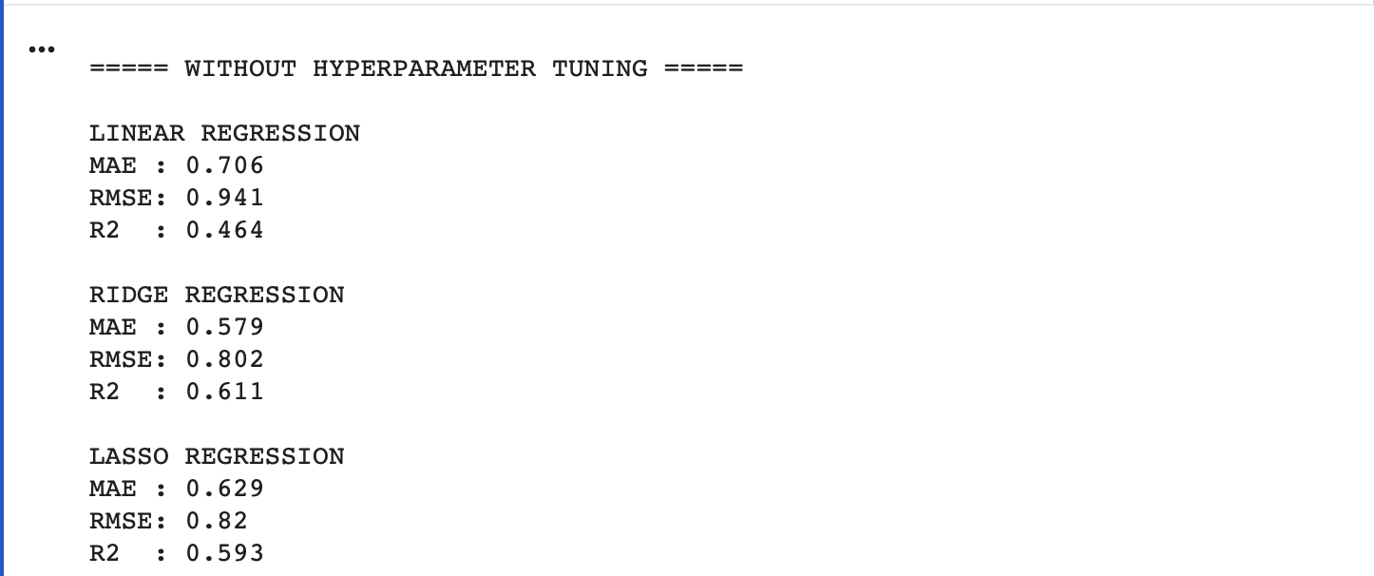

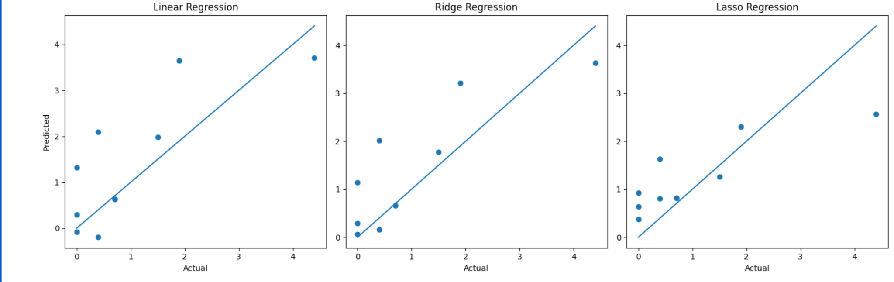

CODE:
With hypermeter tuning
# ============================================
# MULTIPLE + RIDGE + LASSO (WITH TUNING)
# ============================================

import pandas as pd
import numpy as np
import matplotlib.pyplot as plt

from sklearn.model_selection import train_test_split, GridSearchCV
from sklearn.linear_model import LinearRegression, Ridge, Lasso
from sklearn.metrics import mean_absolute_error, mean_squared_error, r2_score
from sklearn.preprocessing import StandardScaler

# --------------------------------------------
# Create Dataset
# --------------------------------------------
data = {
'age': [52,53,70,61,62,58,58,55,46,54,71,43,34,51,52,34,51,54,50,58,
60,67,45,63,42,61,44,58,56,55,44,50,57,70,50,46,51,59,64,57],
'sex': [1,1,1,1,0,0,1,1,1,1,0,0,0,1,1,0,0,1,0,1,
1,0,1,0,0,0,1,0,1,0,1,0,1,1,1,1,1,1,1,1],
'cp': [0,0,0,0,0,0,0,0,0,0,0,0,1,0,0,1,2,0,1,2,
2,0,0,2,2,0,2,1,2,0,0,1,0,2,2,2,3,0,0,2],
'trestbps': [125,140,145,148,138,100,114,160,120,122,112,132,118,140,128,118,140,124,120,140,
140,106,104,135,120,145,130,136,130,180,120,120,130,160,129,150,125,138,128,128],
'chol': [212,203,174,203,294,248,318,289,249,286,149,341,210,298,204,210,308,266,244,211,
185,223,208,252,209,307,233,319,256,327,169,244,131,269,196,231,213,271,263,229],
'fbs': [0,1,0,0,1,0,0,0,0,0,0,1,0,0,1,0,0,0,0,1,
0,0,0,0,0,0,0,1,1,0,0,0,0,0,0,0,0,0,0,0],
'restecg': [1,0,1,1,1,0,2,0,0,0,1,0,1,1,1,1,0,0,1,0,
0,1,0,0,1,0,1,0,0,2,1,1,1,1,1,1,0,0,1,0],
'thalach': [168,155,125,161,106,122,140,145,144,116,125,136,192,122,156,192,142,109,162,165,
155,142,148,172,173,146,179,152,142,117,144,162,115,112,163,147,125,182,105,150],
'exang': [0,1,1,0,0,0,0,1,0,1,0,1,0,1,1,0,0,1,0,0,
0,0,1,0,0,1,1,0,1,1,1,0,1,1,0,0,1,0,1,0],
'oldpeak': [1.0,3.1,2.6,0.0,1.9,1.0,4.4,0.8,0.8,3.2,1.6,3.0,0.7,4.2,1.0,0.7,1.5,2.2,1.1,0.0,
3.0,0.3,3.0,0.0,0.0,1.0,0.4,0.0,0.6,3.4,2.8,1.1,1.2,2.9,0.0,3.6,1.4,0.0,0.2,0.4],
'slope': [2,0,0,2,1,1,0,1,2,1,1,1,2,1,1,2,2,1,2,2,
1,2,1,2,1,1,2,2,1,1,0,2,1,1,2,1,2,2,1,1],
'ca': [2,0,0,1,3,0,3,1,0,2,0,0,0,3,0,0,1,1,0,0,
0,2,0,0,0,0,0,2,1,0,0,0,1,1,0,0,1,0,1,1],
'thal': [3,3,3,3,2,2,1,3,3,2,2,3,2,3,0,2,2,3,2,2,
2,2,2,2,2,3,2,2,1,2,1,2,3,3,2,2,2,2,3,3],
'target': [0,0,0,0,0,1,0,0,0,0,1,0,1,0,0,1,1,0,1,1,
0,1,1,1,1,0,1,0,0,0,0,1,0,0,1,0,1,1,1,0]
}

df = pd.DataFrame(data)

# --------------------------------------------
# Prepare Data
# --------------------------------------------
X = df.drop(['oldpeak', 'target'], axis=1)
y = df['oldpeak']

X_train, X_test, y_train, y_test = train_test_split(
X, y, test_size=0.25, random_state=42
)

# Scaling
scaler = StandardScaler()
X_train = scaler.fit_transform(X_train)
X_test = scaler.transform(X_test)

# --------------------------------------------
# Linear Regression (baseline)
# --------------------------------------------
linear = LinearRegression()
linear.fit(X_train, y_train)
y_pred_linear = linear.predict(X_test)

# --------------------------------------------
# Hyperparameter Tuning
# --------------------------------------------
alpha_values = {'alpha': [0.001, 0.01, 0.1, 1, 10, 100]}

# Ridge Tuning
ridge = Ridge()
ridge_grid = GridSearchCV(ridge, alpha_values, cv=5, scoring='neg_mean_squared_error')
ridge_grid.fit(X_train, y_train)

best_ridge = ridge_grid.best_estimator_
y_pred_ridge = best_ridge.predict(X_test)

# Lasso Tuning
lasso = Lasso(max_iter=10000)
lasso_grid = GridSearchCV(lasso, alpha_values, cv=5, scoring='neg_mean_squared_error')
lasso_grid.fit(X_train, y_train)

best_lasso = lasso_grid.best_estimator_
y_pred_lasso = best_lasso.predict(X_test)

# --------------------------------------------
# Evaluation
# --------------------------------------------
print("\n===== WITH HYPERPARAMETER TUNING =====")

def evaluate(name, y_true, y_pred):
print(f"\n{name}")
print("MAE :", round(mean_absolute_error(y_true, y_pred), 3))
print("RMSE:", round(np.sqrt(mean_squared_error(y_true, y_pred)), 3))
print("R2 :", round(r2_score(y_true, y_pred), 3))

evaluate("LINEAR REGRESSION", y_test, y_pred_linear)

print("\nBest Ridge Alpha:", ridge_grid.best_params_['alpha'])
evaluate("RIDGE REGRESSION (TUNED)", y_test, y_pred_ridge)

print("\nBest Lasso Alpha:", lasso_grid.best_params_['alpha'])
evaluate("LASSO REGRESSION (TUNED)", y_test, y_pred_lasso)

# --------------------------------------------
# Graph Output
# --------------------------------------------
plt.figure(figsize=(15,5))

plt.subplot(1,3,1)
plt.scatter(y_test, y_pred_linear)
plt.plot([y.min(), y.max()], [y.min(), y.max()])
plt.title("Linear Regression")
plt.xlabel("Actual")
plt.ylabel("Predicted")

plt.subplot(1,3,2)
plt.scatter(y_test, y_pred_ridge)
plt.plot([y.min(), y.max()], [y.min(), y.max()])
plt.title("Ridge (Tuned)")
plt.xlabel("Actual")

plt.subplot(1,3,3)
plt.scatter(y_test, y_pred_lasso)
plt.plot([y.min(), y.max()], [y.min(), y.max()])
plt.title("Lasso (Tuned)")
plt.xlabel("Actual")

plt.tight_layout()
plt.show()

# --------------------------------------------
# Lasso Feature Selection
# --------------------------------------------
lasso_coeff = pd.Series(best_lasso.coef_, index=X.columns)

plt.figure(figsize=(8,5))
lasso_coeff.plot(kind='bar')
plt.title("Feature Importance (Lasso)")
plt.ylabel("Coefficient Value")
plt.show()

OUTPUT:
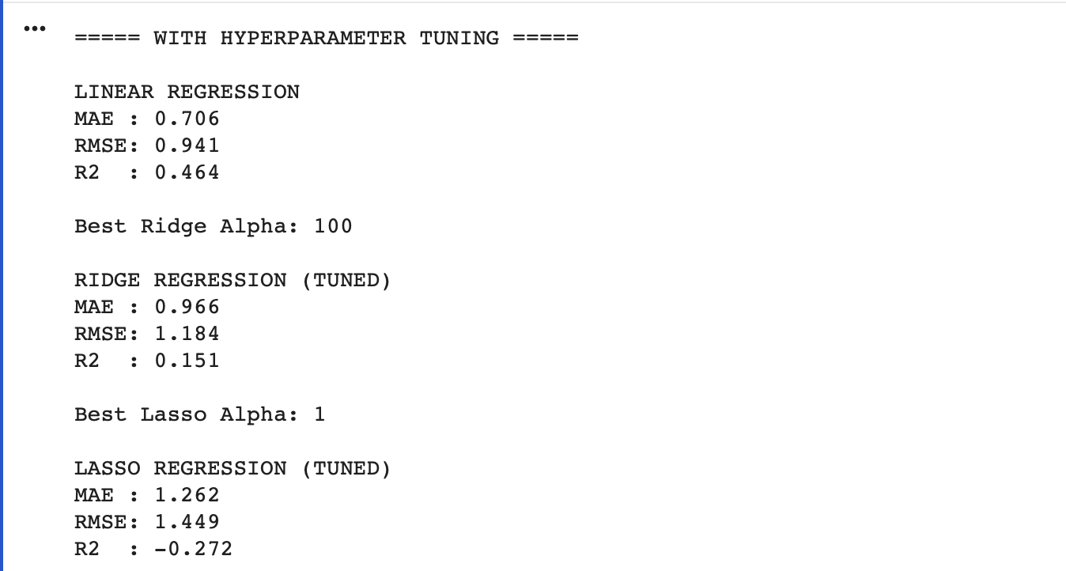
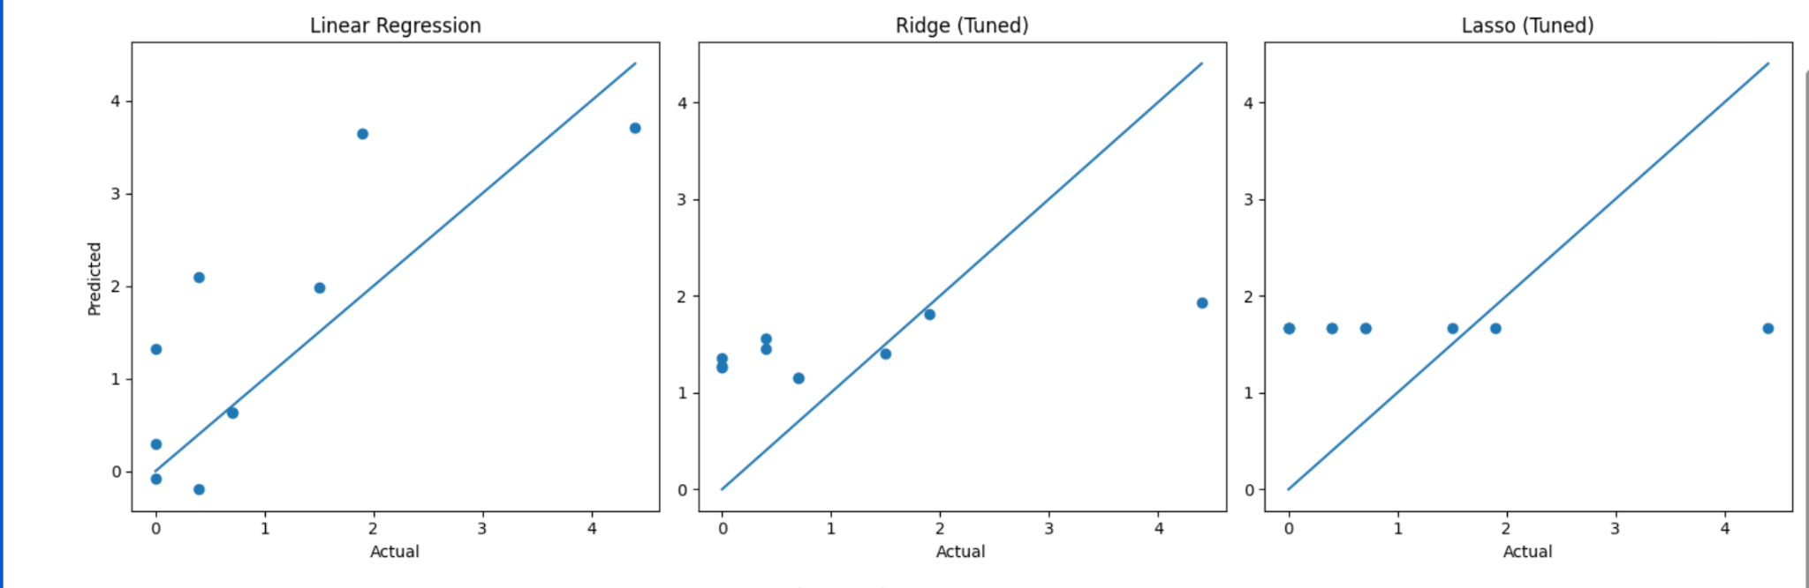

Difference between Without and With Hyperparameter Tuning:
Without hyperparameter tuning, fixed values of alpha are used, which may not give the best performance. The model shows moderate accuracy and higher error.
With hyperparameter tuning, the optimal alpha value is selected using techniques like GridSearchCV. This improves accuracy, reduces error, and gives better model performance.

